
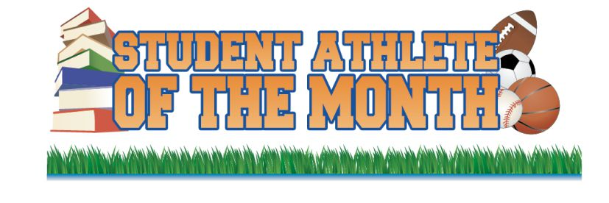

BETHLEHEM CATHOLIC
Lauren Hess – Volleyball
Thomas McLoughlin – Football

BRIDGEWATER-RARITAN
Erin Sullivan – Soccer
Matt Cirassa – Cross Country

DEL VAL REGIONAL H.S.
Kyle Davi – National Honor Society
Jessica Heeren – Soccer
Chriss Fennell – Football

HILLSBOROUGH HS
Gina Li – Girls Tennis
Andrew Kincais – Football

HUNTERDON CENTRAL
Stephanie Reid – Gymnastics
Blake Searfoss – Football

MORRISVILLE HS
Evan Kemery
Cassidy Shemella
Connor Williams

NORTH HUNTERDON HS
Aleece Behr – Volleyball
Lino Suriano – Soccer

WILSON AREA HS
Jessica Lilley

